ASSIGNMENT SESSION – 4

- Create a simple JavaScript function called calculateTotal that takes two numbers: itemPrice and quantity, and returns the total bill amount using arithmetic operators. 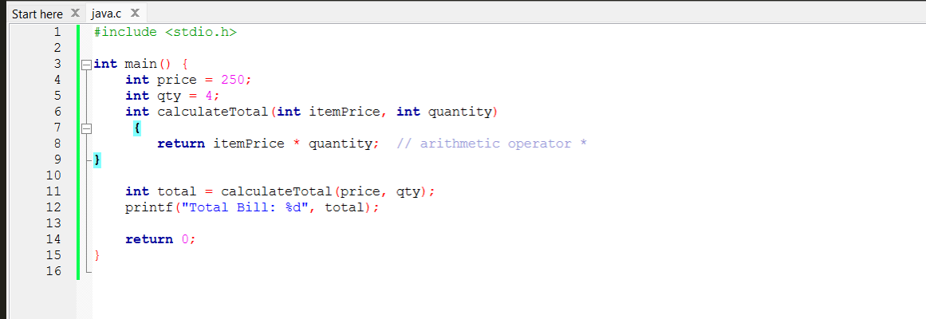

OUTPUT:
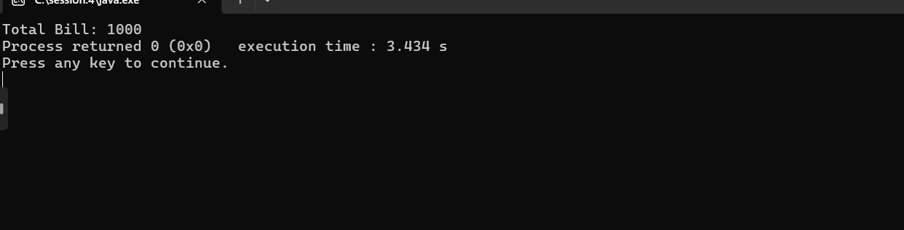

- Build a Flipkart-style discount calculator: given product price, discount percentage, and a boolean isMember, use arithmetic and logical operators to calculate the final price (apply an extra 5% off if isMember is true).
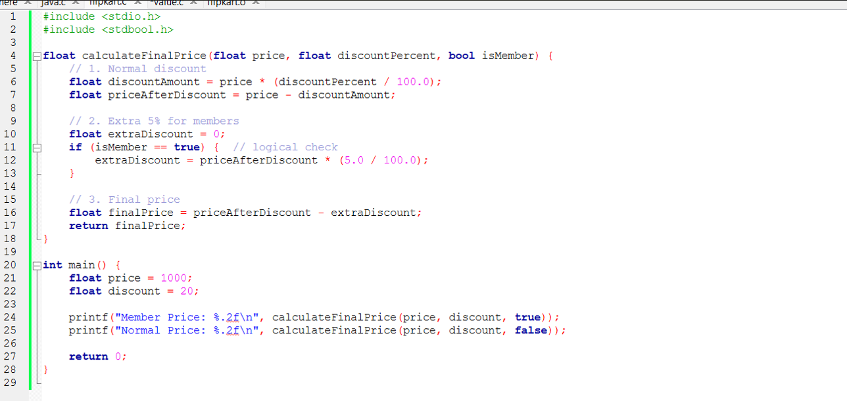
OUTPUT:
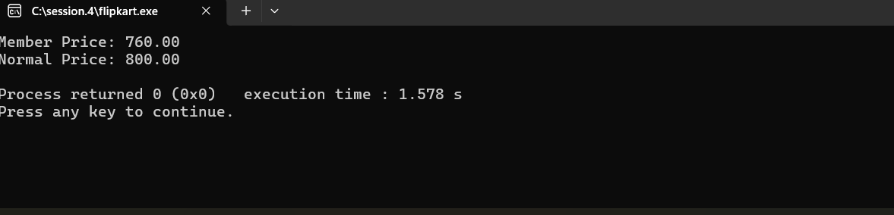

- Write a function isEligibleForOffer that takes a user's age and total order value, and returns true if the user is 18 or older AND the order value is above 500, otherwise false.<br><br><em><strong>Hint:</strong> Use relational and logical operators together.</em>
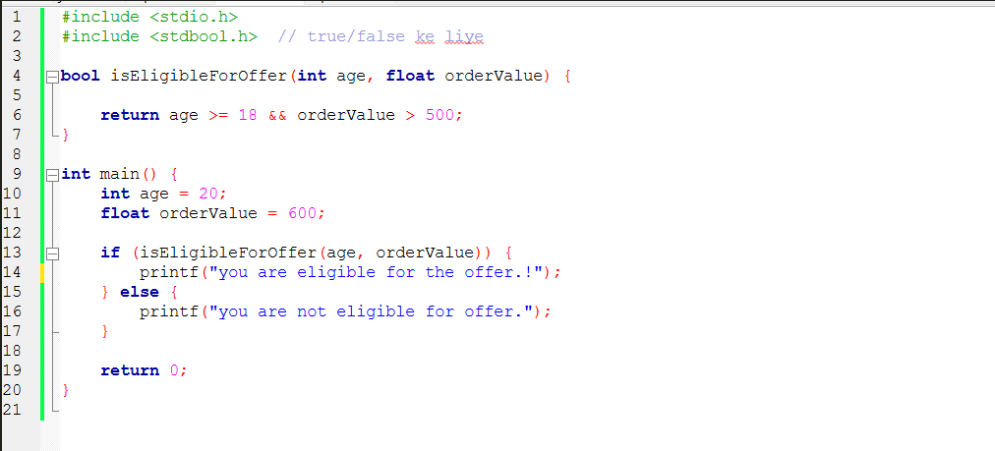
OUTPUT:
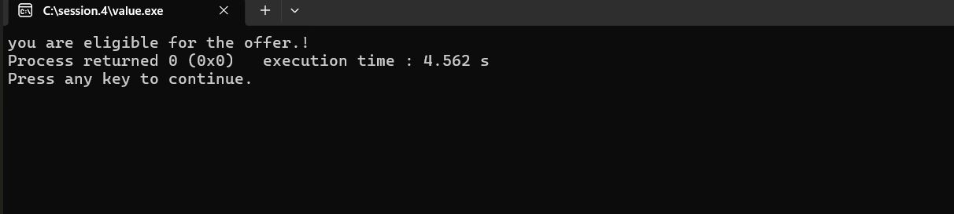

- Given three variables: likes, comments, and shares (all numbers), write code to check if a post is 'trending' on Instagram (at least 1000 likes OR more than 200 comments AND at least 50 shares). Print the result.
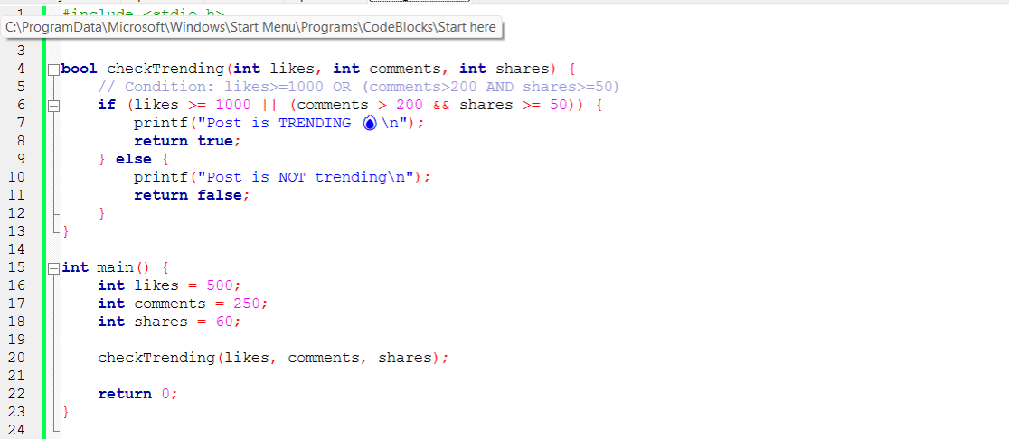
OUTPUT:
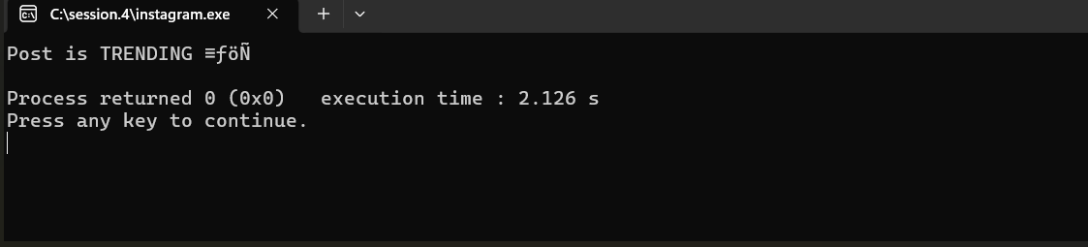

- Write a code snippet that demonstrates the difference between pre-increment (++count) and post-increment (count++) by logging the values before and after using both on a followerCount variable.
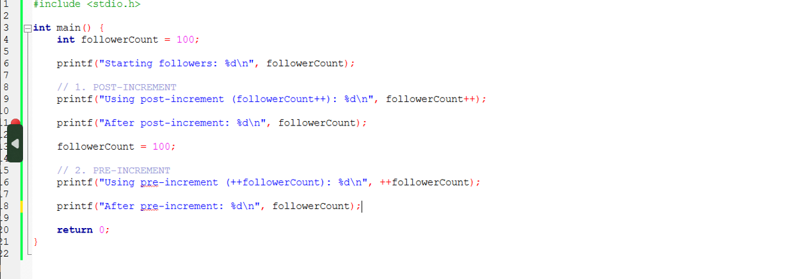
OUTPUT:
